EXPERIMENT-8
8) Perform basic Image Handling and processing operations on the image is to read an image in python and Dilate an Image using Dilate function.
a) CODE
import cv2
img = cv2.imread("photo.jpg")
kernel = cv2.getStructuringElement(cv2.MORPH_RECT, (5,5))
dilate = cv2.dilate(img, kernel)
cv2.imwrite("dilated.jpg", dilate)
print("Image dilated successfully")

b) INPUT
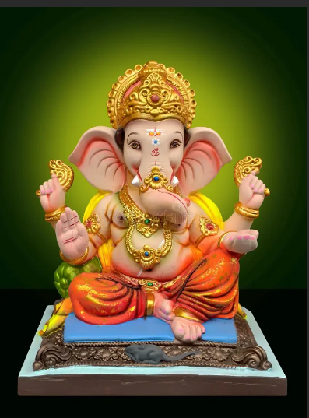

c) OUTPUT
